



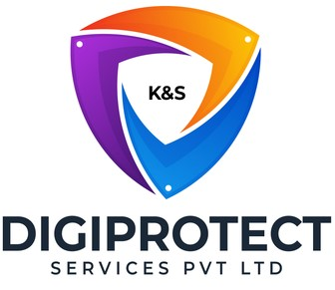

INITIAL
ASSESSMENT
REPORT

DATE:02nd July 2024
Operations

VERSION: 1.2

Document History
Document version | Remarks | Submitted  By | Submission  Date | Approved BY | Approval  Date
1.0 | First Draft | k&S Digiprotect | 12th June 2024
1.1 | Second Draft | k&S Digiprotect | 18th June 2024
1.2 | Third Draft | k&S Digiprotect | 2nd July 2024

Table of Contents
Introduction 4
Objectives 4
General Information 5
SPOC Information 5
Department Hierarchy* 6
Observations 7
Data Flow Diagram 9
Data Mapping and Inventory 10
Recommendations 12
Conclusion 13
Appendices 14
Appendix A 14

Introduction
The Operations Department plays an important role in the overall functioning of India Shelter Finance Corporation Limited (ISFC), acting as the central hub for all major operational activities. It is responsible for ensuring seamless coordination among various departments, managing day-to-day operations, and maintaining the efficiency and effectiveness of processes critical to the organization's success. By overseeing functions such as document verification, loan processing, disbursement, loan closures, and field verifications, the Operations Department guarantees that the operational activities comply with regulatory requirements and support the company’s strategic objectives.
This report encapsulates critical insights for As-Is study, derived from the initial interview conducted with the Operations Department of India Shelter Finance Corporation Limited (ISFC) for the implementation of ISO/IEC 27001:2022 and compliance with the Digital Personal Data Protection Act (DPDPA).
The overarching objectives of this interview were dual fold: first, to gain an understanding of the departmental structure, and second, to delve into the core operational processes of the Operations Department. Additionally, the interview aimed to assess the existing information security practices, focusing on evaluating adherence to DPDPA requirements and the readiness for ISO/IEC 27001:2022 implementation.
By delving into the details of the department's organizational setup, operational workflows, and data handling procedures, this report aims to identify both the strengths and areas of improvement in information security management and DPDPA compliance within the department.

Objectives
- Understand the departmental hierarchy and reporting structure
- Learn the existing processes of ISFC’s Operations Department
- Mapping of existing processes with documented processes
- Offer recommendations to optimize the existing processes

General Information
Organization Name | India Shelter Finance Corporation Limited
Department Name | Operations Department
Date of the Assessment | 26th April 2024
Location | 6th Floor, India Shelter HQ, Gurugram
Meeting Duration | 30 minutes
Attendees (ISFC) | Manu Soni, Himanshu Lohia, Dheeraj Yadav, Sunil Kumar Sharma
Attendees (Digiprotect) | Lalit Mohan Joshi, Sushil Menon, Adhita Razdan

SPOC Information
Project SPOC: Dheeraj Yadav
Contact Information:
Email ID: dheeraj.yadav@indiashelter.in

Project Coordinator: Sunil Kumar Sharma
Contact Information:
Email ID: sunil.sharma2@indiashelter.in

Department SPOC: Himanshu Lohia
Contact Information:
Email ID: himanshu.lohia@indiashelter.in

Department Hierarchy*

* As given by Operations team

Observations
S. No. | Key Activities | Observations and Asks | Remarks
 | Sales Conversion and Application Processing  - Customer information and lead data is uploaded on the iSales Application by the sales team, which is integrated with the CRM system, Salesforce.  - A new loan file is created for processing.  - The initial loan application is then reviewed by the operations team for completeness and accuracy, ensuring all required fields and preliminary documents are uploaded.  - In cases where additional information or documents are needed, the Operations team coordinates with loan officers to reach out to customers and obtain the necessary details before proceeding with the loan application.  - This process involves checking 40-45 documents, conducting disbursement hygiene checks, and scanning documents before disbursement. | NA | NA
 | Credit Appraisal and Technical Validation  - The verified documents are sent to the credit team for technical validation and credit appraisal which is done through the iCredit App.  - Field visits are conducted for physical verification of documents, which are then processed via the iCredit App.  - The loan application status is communicated to the customer and sales team, outlining any conditions or requirements for disbursement. | NA | NA
 | Disbursement Process Management  - After technical valuation, field visits, and document verification is done, the disbursement process is initiated.  - Hygiene checks are performed to ensure all pre-disbursement conditions are met.  - Physical documents are validated at HO before proceeding with the final disbursement.  - The operations team informs the Loan Accounting team for the final disbursement amount.  - The fund transfer to the customer’s/sellers account is carried out by the loan accounting team, ensuring all financial protocols are followed.  - Disbursement details are then recorded in Salesforce. | - Edit rights on Salesforce is with only 2-3 people in the central operations team. | NA
 | Loan Closure and Document Retrieval  - Loan closure involves returning of property papers, issuing of NOC, which are sent from HO to branch and then to customers via DTDC.  - Physical documents are scanned and validated before finalizing the closure. | - Unused cheques are no more returned to customer and the same is mentioned on the NOC as well  - The acknowledgement from customer taken at the time of returning Property documents, is scanned and uploaded in Sales Force and further the same is verified by the HO. | NA
 | Access Management  - Newly joined employees receive view-only access initially and gain full rights post-training, allowing them to start a few cases. | NA | NA

Data Flow Diagram
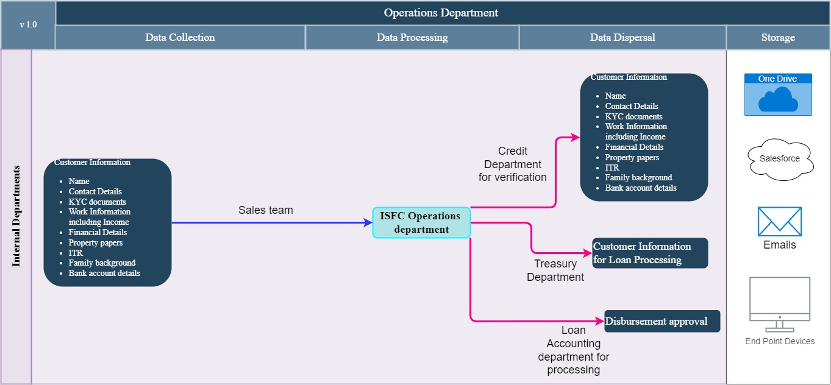

Data Mapping and Inventory
S. No | Data Category | Description | Purpose | Data Owner | Storage Location | Data Classification* | Retention Period | Legal Basis
1 | Loan Application Documents | Documents submitted by customers for loan application | To assess and process home loan applications | Operations Department | iSales App, iCredit App, Salesforce | PII/  Sensitive | As per regulatory requirements | Legitimate Interest, Consent
2 | Physical Verification Data | Data collected during field visits for document verification | To verify the authenticity of submitted documents | Field Verification Team | Secure physical storage, iCredit App | PII/  Sensitive | As per regulatory requirements | Legitimate Interest, Consent
3 | Loan Agreement Documents | 40-45 documents involved in the loan agreement process | To finalize and legally bind the loan agreement | Operations Department | Scanned and stored in secure digital storage | PII/  Sensitive | As per regulatory requirements | Legitimate Interest, Consent
4 | Disbursement Hygiene Checks | Details of hygiene checks conducted before disbursement | To ensure compliance and accuracy before loan disbursement | Operations Department | iSales App, iCredit App | PII/  Sensitive | As per regulatory requirements | Legitimate Interest, Contract
5 | Loan Closure Documents | Documents related to the closure of loans | To manage the return of property papers and close loans | Operations Department | HO, Branch storage | PII/  Sensitive | As per regulatory requirements | Legitimate Interest, Contract
6 | Document Access Records | Logs of document access and modifications | To maintain accountability and facilitate audits | IT Department | Secure digital logs | Non PII/  Restricted | As per regulatory requirements | Legal Obligation
7 | Employee Access Records | Access levels and permissions for employees | To manage access controls and ensure data security | Operations Department | Secure digital storage | Non PII/  Restricted | Duration of employment and regulatory requirements | Legitimate Interest
8 | MIS Reports | Management Information System reports | To keep teams informed and aligned with goals | Operations Department | Internal secure storage | PII/  Sensitive | As per regulatory requirements | Legitimate Interest
9 | Disbursement Details | Data related to disbursement activities | To manage and track loan disbursements | Operations and Loan Accounting Team | Internal secure storage | Non PII/ Restricted | As per regulatory requirements | Legitimate Interest, Contract
*Refer Appendix A

Recommendations
- Document Processing and Verification
  - Secure Document Handling through iSales and iCredit Apps
- Ensure that all documents processed through iSales and iCredit Apps are encrypted both in transit and at rest to protect sensitive information.
- Maintain detailed logs of document access and modifications to ensure accountability and facilitate audits.
- All mobile apps to be assessed for data protection and privacy measures.

  - Comprehensive Loan Agreement Checks
- Only collect and process documents that are absolutely necessary for the loan agreement process to ensure data minimization.
- Ensure that scanned documents are immediately encrypted and stored securely to prevent unauthorized access.

- Field Verification and Document Handling
- Secure Physical Verification
- Ensure that documents handled during field verification are securely transported and stored to prevent unauthorized access.

- Quarterly Reporting
- Generate detailed quarterly reports that include file checks and the quality of disbursements. These reports should highlight any discrepancies and areas for improvement.
- Ensure reports are DPDPA-compliant, anonymizing personal data where possible and restricting access to necessary personnel only.

- Disbursement Process Management
- Centralized and Secure Disbursement Handling
- Ensure that all disbursement activities managed by Operation Executives at HO are conducted through secure systems with encryption and access controls.
- Validate and securely process pre-closure payments to ensure accuracy and prevent fraud.

- MIS Integration and Security
- Ensure that MIS data is accurate, up-to-date, and reflects real-time disbursement statuses.
- Strictly control the sharing of Personally Identifiable Information (PII) within MIS. Only 2-3 authorized central team members should have access to sensitive data.

- Physical Document Validation
- Conduct all physical document validations at HO, using secure protocols to ensure the integrity and security of documents before final disbursement.
- Perform regular audits of physical document handling processes to ensure compliance with information security policies and DPDPA requirements.

Conclusion
The operations department is the backbone of India Shelter Finance Corporation Limited (ISFC). It ensures the smooth functioning of all the essential activities that keep the ISFC running efficiently.
Their key functions include:
Loan Closure and Document Retrieval:
- Informing the retrieval team for property paper return, managed from HO to branch and then to customers via DTDC.
- Regular tracking and timely retrieval of loan closure documents.
Access Management:
- New joiners receive view-only access initially and gain full rights post-training
- Proper training protocols and access rights are crucial for operational efficiency and security.
- Branch teams do not have access to these systems. (Salesforce, and FinnOne)
Field Verification and Document Handling:
- Field visits are conducted for physical verification of documents.
- Team ensures that all documents are complete and accurate before proceeding with disbursement.
- Quarterly reports are generated and shared, detailing file checks and quality of disbursements
- The loan agreement process involves checking 40-45 documents, disbursement hygiene checks, and document scanning before disbursement.
Disbursement Process Management:
- Disbursement activities are handled by Operation Executives at HO for statements and pre-closure payments.
- The process is initiated by MIS triggered by the system Salesforce, and FinnOne. Regular MIS is selected in business cache MIS TIS
- Physical documents are validated at HO before final disbursement.

Overall, ISFC’s operations department is the bridge between the ISFC's financial products and its customers. It strives for accuracy, efficiency, and compliance to ensure a seamless financial experience for both borrowers and ISFC itself.

Appendices

Appendix A
Data Classification | Definition
Sensitive Data | Information that, if disclosed, altered, or destroyed without authorization, could cause significant harm to an individual, organization, or entity. This often includes financial records, medical information, and PII.
Restricted Data | Highly sensitive data tightly controlled due to legal, regulatory, or contractual requirements. Access is limited to authorized personnel, and any unauthorized disclosure may result in severe consequences.
Private Data | Information considered confidential and intended solely for specific individuals or groups within an organization. It requires protection from unauthorized access to maintain privacy and uphold confidentiality agreements.
Confidential Data | Privileged or proprietary information of an organization requiring protection from unauthorized access, disclosure, or alteration.
Public Data | Information that is freely available and accessible to the general public without restrictions or limitations. It does not contain sensitive or confidential information and can be openly accessed and used for various purposes such as research, analysis, and public interest initiatives.
PII (Personally Identifiable Information) | Data that can identify, contact, or locate an individual, either alone or in combination with other information. For example - names, addresses, official identifiers (Aadhar, Pan, DL, biometrics, etc).
Non-PII | Data that, while not personally identifiable, however may still require protection due to its sensitivity or confidentiality. This may include corporate financial information, proprietary research data, or internal communications.

--------------------------------------End of report for Operations Department ------------------------------

